**Title: Driver Information Management**

**Driver Info**

* did, name, licenseno

**Tasks**

* Insert new driver
* Search driver
* Edit driver
* Delete driver
* Display all drivers

Solutions

a. Common

Use Case

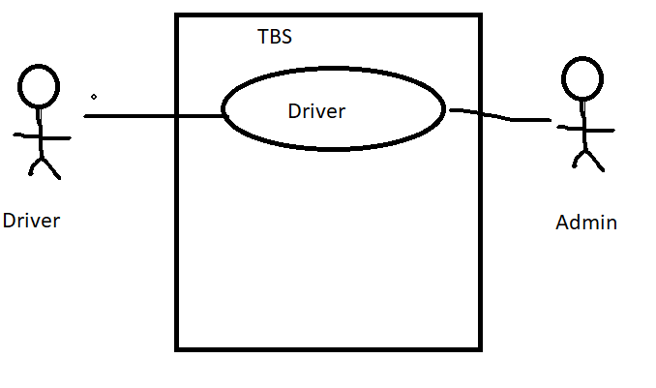

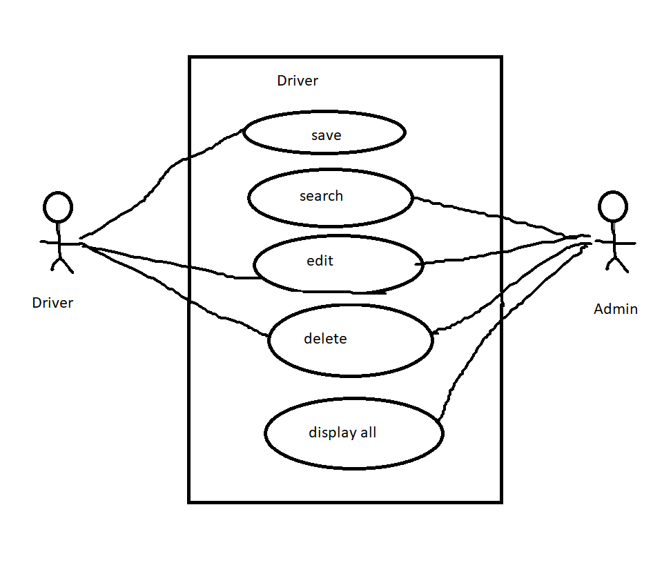

Database Design

a. Data Dictionary

Driver

|  |  |  |  |  |  |  |
| --- | --- | --- | --- | --- | --- | --- |
| **SN** | **Filed Name** | **Type** | **Length** | **Null** | **Key** | **Description** |
| 1 | did | int | 3 | Not | PK | Store drive id |
| 2 | name | varchar | 50 | Not | - | Store full name |
| 3 | licenseno | varchar | 50 | Not | UK | Store license no |

b. ER Model/Diagram

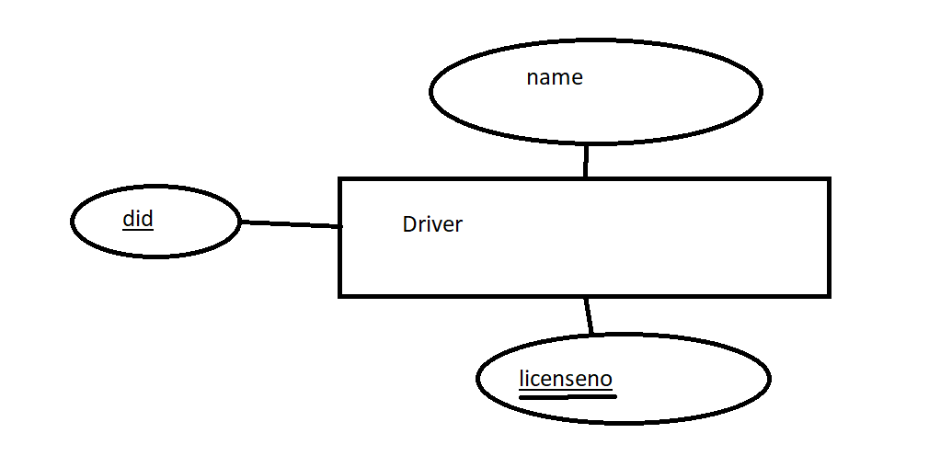

c. Database and Table (Entity) Manage

- Create database (level4d)

- Create table(entity) (drivers)

- Test CRUD SQL Code

Class Diagram

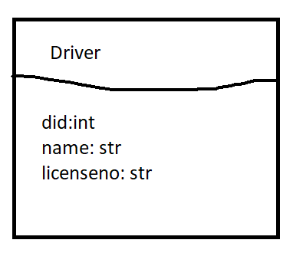

b. Individual

UI/UX

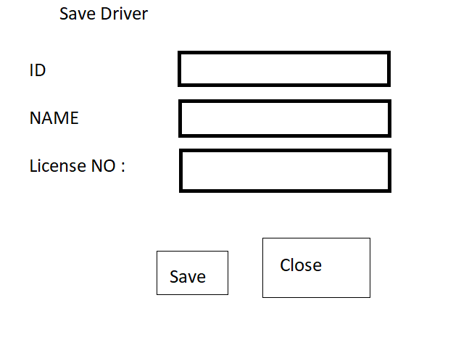

Source code

driver.py

class Driver():

def __init__(self, did=0, name='', licenseno=''):

self.did = did

self.name = name

self.licenseno = licenseno

# getters

def getDID(self):

return self.did

def getName(self):

return self.name

def getLicenceNo(self):

return self.licenseno

# setters

def setDID(self, did):

self.did=did

def setName(self, name):

self.name=name

def setLicenceNo(self, licenseno):

self.licenseno=licenseno

# __ str __

def __str__(self):

return ("{}, {}, {}".format(self.did, self.name, self.licenseno))

MangeDriver.py

**import** mysql.connector  
**import** sys  
**from** driver **import** Driver  
  
**def** saveDriver(driverInfo):  
 conn = **None** sql = **"""INSERT INTO drivers VALUES (%s, %s, %s)"""** values = driverInfo.getDID(), driverInfo.getName(), driverInfo.getLicenceNo()  
 **try**:  
 conn = mysql.connector.connect(  
 host=**'localhost'**,  
 port=**'3306'**,  
 user=**'root'**,  
 password=**''**,  
 database=**'level4d'** )  
 cursor = conn.cursor()  
 cursor.execute(sql, values)  
 conn.commit()  
 cursor.close()  
 conn.close()  
 print(**"Save driver!"**)  
 **except**:  
 print(**"Error: "**, sys.exc_info())  
 **finally**:  
 **del** values  
 **del** sql  
 **del** conn  
  
**def** searchDriver(did):  
 **pass  
def** editDriver(driverInfo):  
 **pass  
def** deleteDriver(did):  
 **pass  
def** allDriver():  
 **pass**

Test case

Test.py

**from** driver **import** Driver  
**from** ManageDriver **import** saveDriver  
*# Test-1*d1 = Driver()  
d1.setDID(1)  
d1.setName(**"Driver1"**)  
d1.setLicenceNo(**"6775555"**)  
saveDriver(d1)